**Ghar Tak**

**Problem Description**:  
In urban and suburban areas, people looking for reliable help with small household tasks, like plumbing and cleaning, face several challenges. These include high prices, limited availability, and poor quality of service. At the same time, rural workers deal with significant unemployment (7.2% in rural areas compared to 6.1% in urban areas), along with few job opportunities and low pay. Existing platforms meant to connect users with service providers often have inefficient processes, complicated registration requirements, and low incentives for workers.

**Problem Validation**:  
The global online home services market is expected to reach USD 1,092.5 million by 2030. However, around 65% of urban users report abandoning online service platforms due to issues with pricing and availability. For rural workers, about 70% have relevant skills but remain underemployed, often earning less than ₹202 per day.

**Existing Solutions & Limitations**:

* **Freelance Platforms** (e.g., Upwork, TaskRabbit): These platforms charge high fees, limiting access for rural workers.
* **Local Classifieds** (e.g., Craigslist): They often lack verification, leading to trust issues for users.
* **Traditional Agencies**: These generally have high prices and limited reach, making them less accessible.
* **Word of Mouth**: This method provides limited options and can be unreliable in unfamiliar areas.

**Proposed Solution and Uniqueness**:  
Ghar Tak Service will connect urban users with verified rural workers for household tasks**.** Users can quickly sign up, select services, and post job requests while tracking worker arrivals in real-time. Workers register with their skills, receive job notifications, and negotiate prices—all within a secure platform that prioritizes privacy and offers performance incentives. Key features include:

* **Dynamic Pricing**: Workers can negotiate prices based on the job's complexity.
* **Job Matching**: Real-time geolocation connects users with nearby workers for quick service.
* **Incentives & Benefits**: Workers earn bonuses and insurance based on their loyalty and performance.
* **Rehiring Option**: Users can easily rehire trusted workers, ensuring reliability and continuity of service.

**Technical Description**:

* **User-Friendly Interface**: The app will have simple navigation for easy job posting and worker selection, providing a smooth user experience.
* **Dynamic Pricing & Task Matching**: Automated algorithms will match users with workers based on location and job type for efficient service.
* **Real-Time Tracking & Notifications**: Users will be able to track worker progress and receive regular updates.
* **Worker Registration**: Workers will go through a verification process via document submission, receive job notifications, and access incentives.

**Feasibility**:

* **Technological**: The service will be built on scalable cloud infrastructure, allowing for real-time geolocation and seamless user interactions.
* **Market**: There is a strong demand for on-demand services, especially in underserved rural communities, which presents a significant market opportunity.

**Prototype images:** 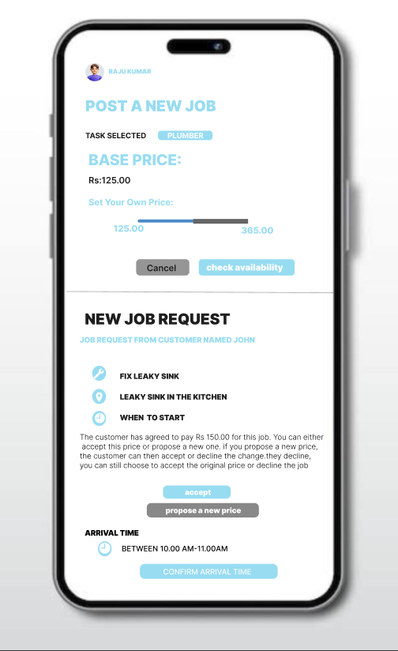

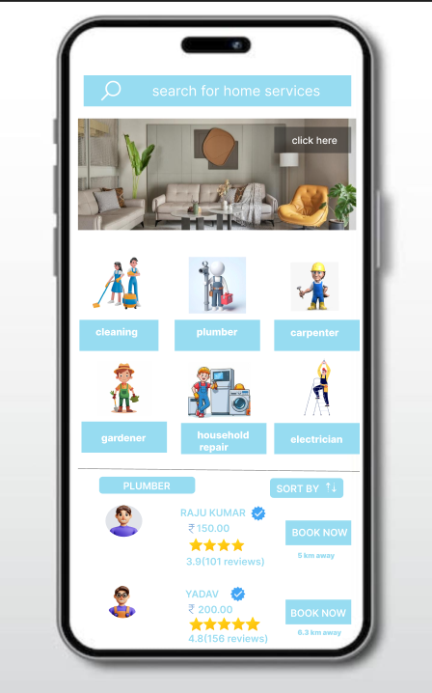

**Conclusion**:  
Ghar Tak Service aims to bridge the gap between urban users and rural workers, providing fair compensation, job opportunities, and access to reliable services. With its focus on real-time tracking, dynamic pricing, and worker incentives, Ghar Tak Service is set to transform the gig economy, benefiting both urban consumers and rural service providers. This approach not only addresses current market inefficiencies but also promotes economic growth in rural communities.